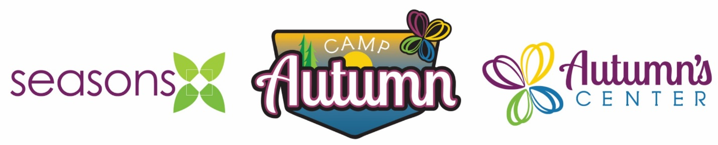NEWS RELEASE
For more information, contact
Adam Lybarger, Camp Director at Camp Autumn
Phone: 1-800-242-5101 | E-mail: alybarger@seasonscenter.org
________________________________________________________________________________

February 16, 2023

For Immediate Release

Ice Fishing Tournament Reeled in $15,022 for Camp Autumn Scholarships

Sutherland, Iowa – Seasons Center for Behavioral Health and Camp Autumn hosted their 4th Annual Ice Fishing Tournament & Fundraiser at Camp Autumn on Saturday, February 11, 2023. One-hundred and eighty-four anglers participated in the event along with twenty-eight sponsors. In total, $15,022 was raised for Camp Autumn’s scholarship program and $6,715 worth of in-kind donations were handed out as tournament prizes, kids' giveaways and to help feed all participants.

In addition to the regular tournament categories for bass, crappie, and other panfish, this year’s tournament also included seven challenge holes and events. In the Kid’s Single Biggest Fish category, Henry Peters caught a 16.75” largemouth bass and won a guided fishing trip with Shane Akin of Great Lakes Guide Service.

“We couldn’t have asked for better weather this year,” said Dan Ries, CEO and President of Seasons Center. “It was a perfect day to be on the ice and we truly appreciate all those who participated in and donated to this event. It’s wonderful to see so many anglers and sponsors continue to support this event year after year. The generosity that’s shown helps make a difference in the lives of so many kids in northwest Iowa.”

The event continues to be supported by the Iowa Great Lakes Fishing Club who coordinates and judges the tournament, as well as provides ice shacks, poles, and gear for individuals or families who do not have ice fishing equipment. Other event sponsors included: AgState, Bobber Down, Boji Custom Metal Works, By the Bucket, C & B Operations, City View Farms, Community State Bank, Darwin & Brenda Johnson, Demco, Everly Lions Club, Great Lakes Guide Service, Hartley Lions Club, Hy-Vee (Spencer), Johnston Auto Stores, Koenig Portable Toilets, Legends Guide Service, Mud on Main (Cherokee), No Limits, Northwest Bank, Northwest Wealth Management, Oak Hill Outdoor, Peterson Lions Club, Royal Lions Club, Snook’s of Okoboji, Stan’s Bait & Tackle, Valero and Vander Haag’s.

“This tournament is the highlight of the winter for me, but it does take a lot of work to put on an event of this size,” said Adam Lybarger, Camp Director at Camp Autumn. “There is just no way we could do it without the generosity of our sponsors, volunteers, and of course the participants. A special thank you to the Iowa Great Lakes Fishing Club and all of their volunteers who work very hard to ensure the tournament runs smoothly and everyone has a great time!”

– 30 –

Founded in 1959, Seasons Center for Behavioral Health continues to be a leading, comprehensive behavioral health center in the northwest region of Iowa. Offering a broad range of behavioral health Services, Seasons recognizes that investing in behavioral health is investing in a community’s economic, education, health and human services systems. Seasons strives to empower individuals so they might become active, contributing members of their communities.

Camp Autumn is dedicated to providing a unique blend of therapy, skill development and fun for those who need it most. Located on a beautiful property near Sutherland, Iowa, Camp Autumn serves children in week-long day camps through the summer and after-school, weekend, and during schools breaks throughout the year. Each camper has a customized treatment plan in order to address the therapeutic and skill development needs of each child. By weaving together the therapeutic aspects of nature, trauma-informed care, and evidence-based practices, campers experience a safe space that promotes health, healing, hope, and fun!

For more information on Seasons’ services or Camp Autumn, please visit www.seasonscenter.org or call 1-800-242-5101.

Avera is a regional partnership of health professionals who share support services to provide excellent care at 300 locations in 100 communities in eastern South Dakota and surrounding states. Our ministry, our people and our superior values distinguish Avera. We carry on the health care legacy of the Benedictine and Presentation Sisters, delivering care in an environment guided by our values of compassion hospitality and stewardship. Avera employs more than 13,500. Inpatient, outpatient and clinic visits totaled nearly 2.5 million in the last year, a number equal to more than twice the population of the Avera service area. For more information please visit www.avera.org.

