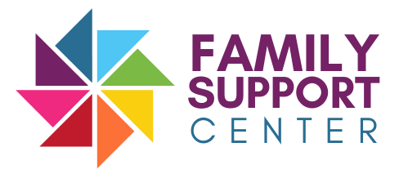
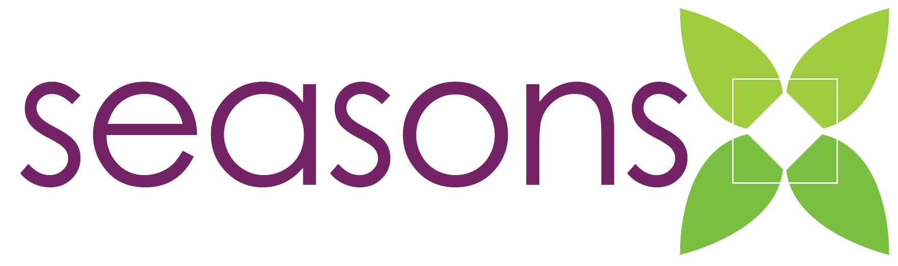
Behavioral Health & Community Resources

For Parents, Caregivers, and for Foster, Adoptive and Kinship Families

ONLINE FORMAT WITH HYPERLINKED RESOURCES*

*adapted from original resource binder

Table of Contents

Please click on the topic to be linked directly to that page
National Resources

Community Resources

Program Information

Foster, Adoptive, Kinship Parents/Caregivers

Parent Preparedness

Adverse Childhood Experiences (ACEs)

Educational Tools for Parents…

Mental Health Briefs

Neonatal Abstinence Syndrome and Fetal Alcohol Spectrum Disorders

Teen Substance Abuse and Mental Health

Activities

Glossary of Terms

NATIONAL RESOURCES
National Child Abuse Prevention Month

Substance Abuse and Mental Health Services Administration (SAMHSA)

National Institute of Mental Health

The National Child Traumatic Stress Network

Administration for Children & Families

Child Welfare Information Gateway

COMMUNITY RESOURCES
Seasons Center for Behavioral Health - General Information
Seasons Center for Behavioral Health - Foster/Adoptive/Kinship Information
Seasons Center for Behavioral Health - Specialized Family Services
Seasons Center for Behavioral Health - Suicide Prevention
Care Connections of Northern Iowa
- Provides a coordinated system of care for citizens experiencing mental health conditions or intellectual disabilities in 6 Iowa Counties: Clay, Osceola, Palo Alto, Kossuth, Winnebago and Worth counties.
Rolling Hills Region
- Services adults with mental health and intellectual disabilities and children with serious emotional disturbances in 10 counties: Buena Vista, Calhoun, Carroll, Cherokee, Crawford, Humboldt, Ida, Pocahontas, Sac and Woodbury.
Sioux Rivers Region
- Provides access, information, and coordination of funding for individuals who experience mental health and intellectual/developmental disabilities and multi-occurring substance use issues, health issues, physical disabilities, brain injuries, and other human service needs. Serving Sioux, Plymouth, Lyon, O’Brien, Dickinson and Emmet counties.

Sioux County
- Includes a variety of resources for different family or individual needs with contact information, such as phone numbers, website links, and summary of services. Available in Spanish.

Community Services Resource Guide Iowa
- Comprehensive resource guide for individuals in Audubon, Dallas, and Guthrie counties. Contains all necessary contact information for resources.

Program Information

2023 Iowa Summer Camps
- From the ASK Resource Center. Provides contact information for currently scheduled camps/activities this upcoming summer.

Free Clinics of Iowa
- Provides basic health care services through volunteer physicians, nurses, and other health professionals at no cost to patients.

Mid-Sioux Opportunity Inc
- Fights poverty and manages 14 federal, state, and local programs that help families grow through educational, health, and financial assistance. Eligibility information available in English and Spanish.

Foster, Adoptive, Kinship Parents/Caregivers

- Financial Kinship Training
  - From the Family Support Center. This information, taken from an online training, covers financial aspects of kinship as explained by professionals in this area.

- Resource Parents Partnership with Birth Parents
  - From the Iowa Foster & Adoptive Parents Association. Explores shared parenting, communication skills, family team meetings, family interactions, and conflict management.

- Foster Parent Handbook
  - From the Iowa Department of Health and Human Services. Introduces information on Iowa codes, culture and religion, payments, foster care insurance, and additional resources. Available in Spanish.

- Ultimate Guide to Iowa Guardianship
  - From O’Flaherty Law. Explores differences in guardianship, eligibility, Iowa’s process, and termination.

- Hidden Hurdles of Kinship Care and Adoption
  - From the National Council of Adoption. Introduces the history of kinship care, unique challenges, permanency, and the role of a professional.

- Grandfacts: Grandfamilies
  - From Grandfamilies. Includes Iowa statistics and information for grandparents who have stepped into caregiver roles. Also includes a variety of resources with necessary contact information. Available in Spanish.

Parent Preparedness

- Safe Coping Skills
  - From Seeking Safety by Lisa M. Najavits. Includes safe coping sheet and safe coping skills with various examples for easy application.

- Improving and Maintaining Healthy Sleep Habits
  - From the University of Wisconsin-Madison. Offers information on insomnia, an integrative approach to treating insomnia, and additional techniques.

- Teens with Traumatic Grief
  - From the National Child Traumatic Stress Network. A simple one page document that discusses ways to recognize and help a teen experiencing traumatic grief. Available in Spanish.

- Nonverbal Communications: Babies
  - From Nursery World. Introduces general signs and unique messages from babies, challenges, and the importance of tone of voice, touch, and eye contact.

- Tips for Parenting Anxious Children
  - From the Child Mind Institute. Offers ten tips for parents to help children cope with anxiety without reinforcing it. Available in Spanish.

Adverse Childhood Experiences (ACES)

- Parenting to Prevent and Heal ACES
  - From PACES connection. Contains a short brief on scientifically supported and relatively simple steps that help reboot the brain, create new pathways, and promote healing. Available in Spanish.

- Helping Children Cope with a Traumatic Event
  - From the Child Mind Institute. Includes information on helping children cope after a traumatic event, broken down into four different age categories. Also explores the role of teachers and common signs of trauma in children. Available in Spanish.

Educational Tools for Parents

- Ultimate ADHD Toolkit
  - From ADDitude School Resources. Offers fourteen tools, such as checklists, charts, worksheets, letters, and conversation starters that help parents, children, and teachers create a successful school year.

Mental Health Briefs

- Children and Mental Health
  - From the National Institute of Mental Health. Discusses topics regarding mental health in childhood like when to seek help, first steps for parents, treatment options, and how to work with a school. Available in Spanish.
- The National Institute of Mental Health also has briefs on a variety of mental health topics that impact families, such as:
  - Autism Spectrum Disorder (English) (Spanish)
  - Depression (English) (Spanish)
  - Generalized Anxiety Disorder (English) (Spanish)
  - Post Traumatic Stress Disorder (English) (Spanish).

Neonatal Abstinence Syndrome and Fetal Alcohol Spectrum Disorders

- Understanding Fetal Alcohol Spectrum Disorders
  - From the National Center on Substance Abuse and Child Welfare. Discusses prevalence, symptoms and effects, treatment and services, and more. Similar resource from the CDC available in Spanish.

- Misdiagnosis and Missed Diagnosis in Foster/Adopted Children
  - From Ira Chasnof. A study that explores the rate of misdiagnosis and missed diagnosis of fetal alcohol spectrum disorder in foster and adopted youth.

Teen Substance Abuse and Mental Health

- Disrupting Stigma
  - From the National Center on Substance Abuse and Child Welfare. Explores how families can use understanding, empathy, and connection to improve outcomes with substance use and mental health.

- Understanding Suicide
  - From the CDC. A short fact sheet on why suicide is a public health problem, who is at risk for suicide, and how to prevent suicide.

- Safety Plans
  - From Stanley and Brown. A one page worksheet for safety planning, including spots for coping strategies, safe people, places, and agencies.

- Preventing Sexual Violence
  - From the CDC. Explores the problem, the repercussions, and prevention.

Activities

- Stress Catcher
  - From the National Institute of Mental Health. Details an activity that allows individuals to catch some great coping strategies and skills for managing stress. Available in Spanish.

- This is Me: Lifebook Activity
  - From Iowa Foster and Adoptive Parents Association. A multi-page book that can be printed and filled out with the child to explore who they are. Available in Spanish.

Glossary of Terms

- Child Welfare Glossary
  - From Child Welfare Information Gateway. Includes an alphabetical list of definitions for common terms and acronyms. Available in Spanish.

- Sexual Orientation Glossary
  - From the Center of Excellence on LGBTQ+ Behavioral Health Equity. Defines terms related to sexual orientation, gender identity, and expression. Available in Spanish.

This resource was supported by the Health Resources and Services Administration (HRSA) of the U.S. Department of Health and Human Services (HHS) as part of an award totaling $200,000 with 0% percent financed with non-governmental sources. The contents are those of the author(s) and do not necessarily represent the official views of, nor an endorsement, by HRSA, HHS, or the U.S. Government. For more information, please visit HRSA.gov.
This resource was developed under grant number 1H79SM084884-01 from the Substance Abuse and Mental Health Services Administration (SAMHSA), U.S. Department of Health and Human Services (HHS). The views, policies, and opinions expressed are those of the authors and do not necessarily reflect those of SAMHSA or HHS.

