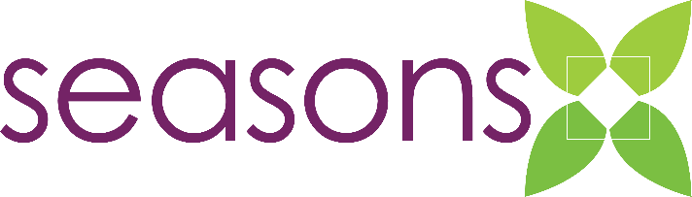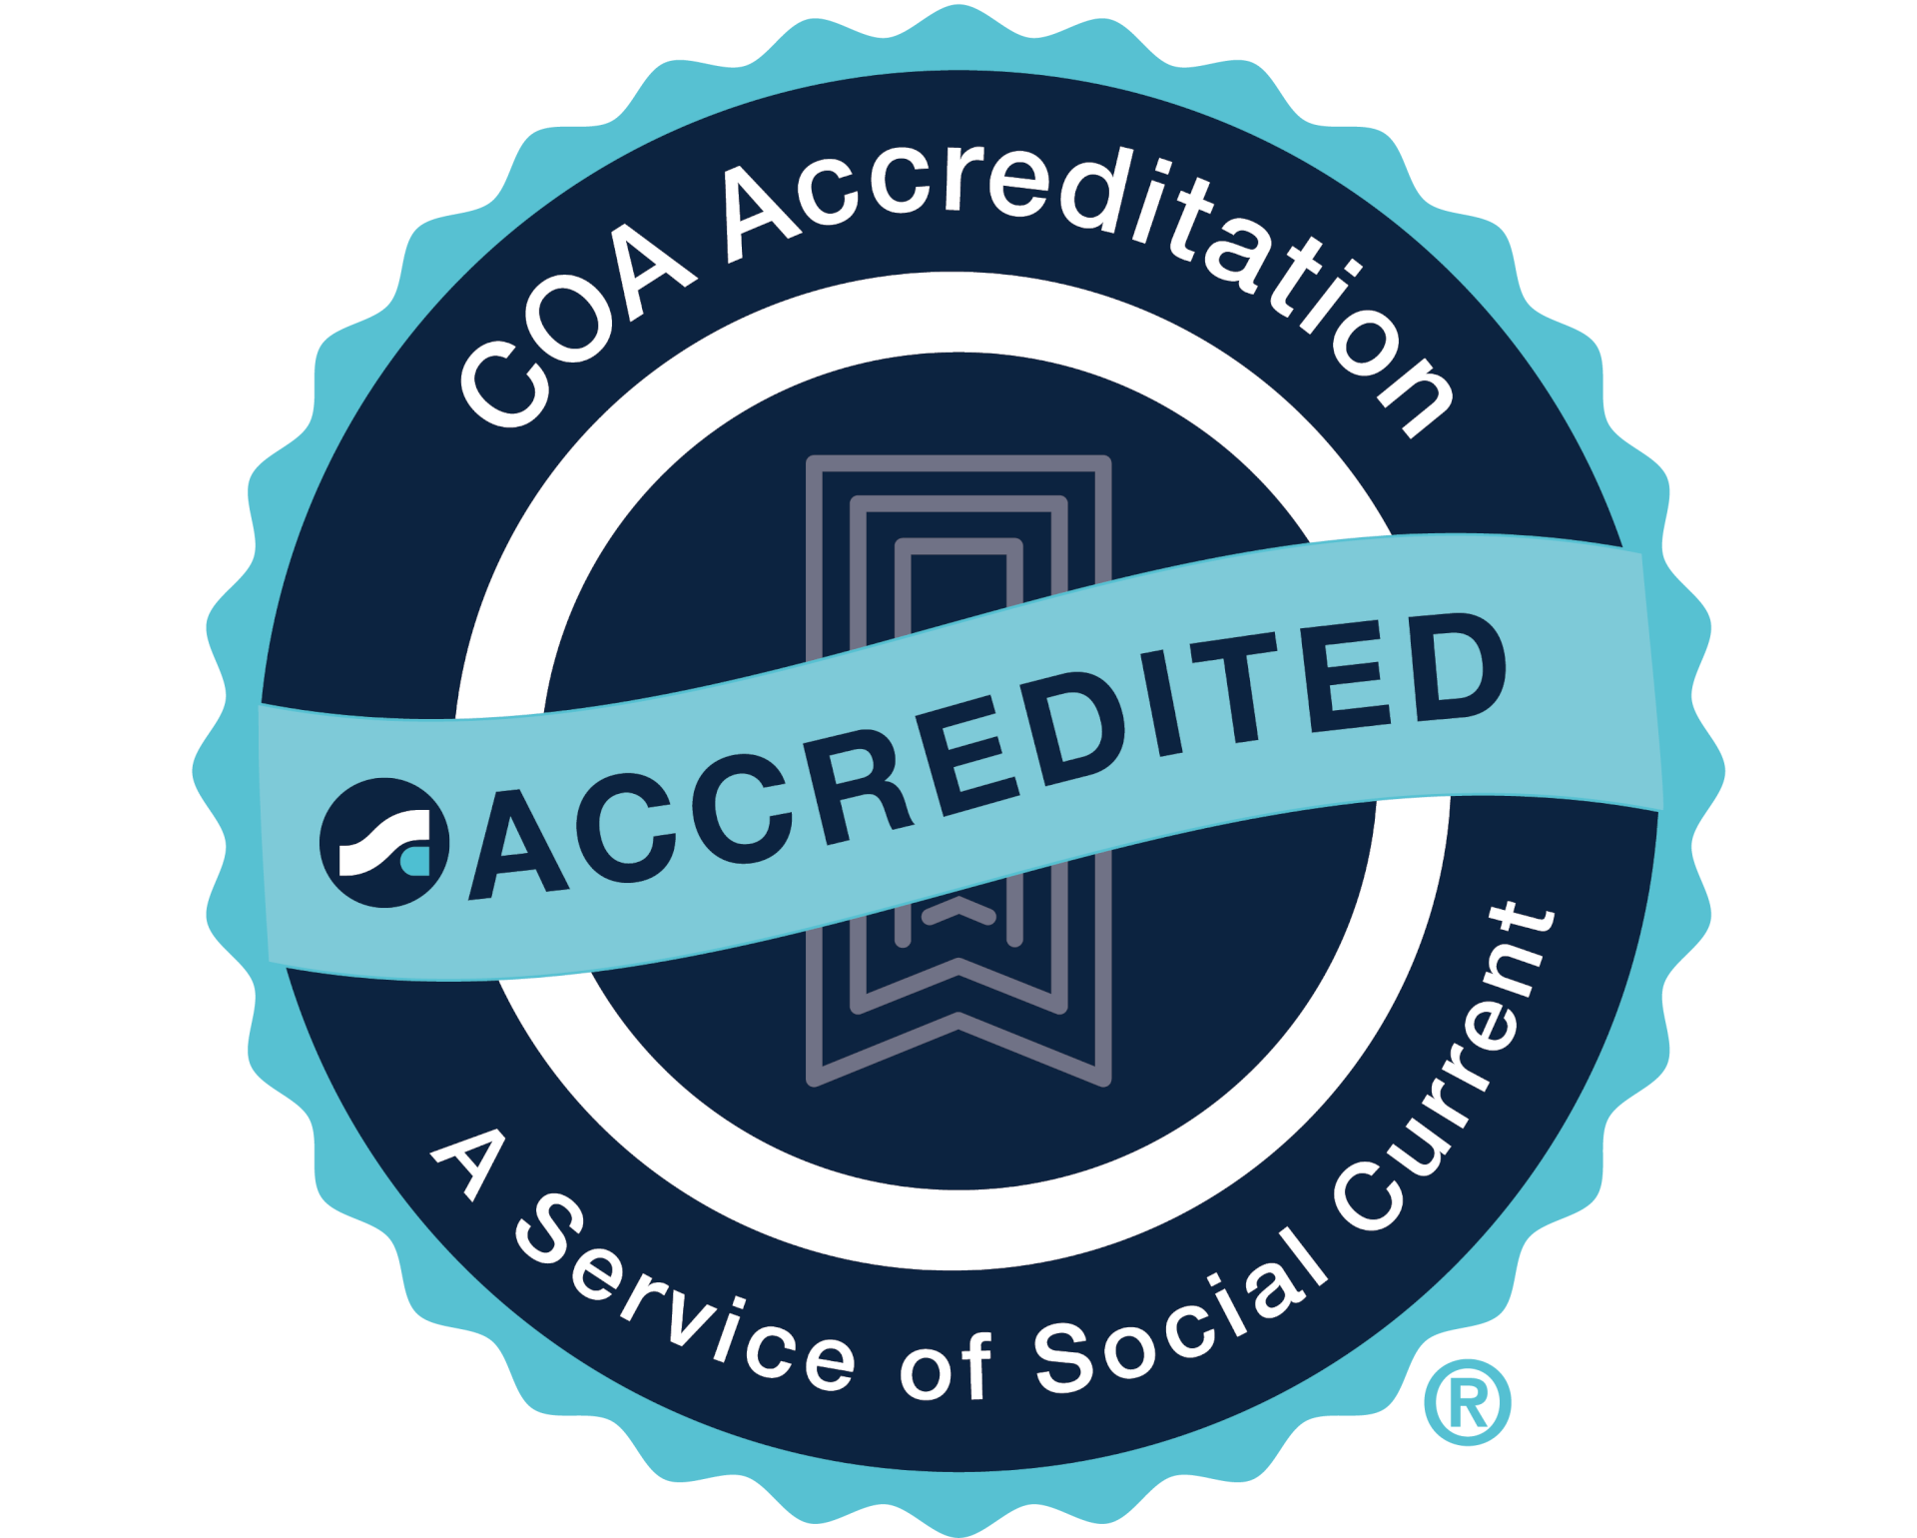
NEWS RELEASE
For more information contact Dan Ries, President & CEO
Phone: 712-262-2922 x1116 | E-mail: dries@seasonscenter.org
________________________________________________________________________________

January 9, 2026

FOR IMMEDIATE RELEASE

Seasons Center for Behavioral Health Earns COA Accreditation

Spencer, Iowa: Seasons Center for Behavioral Health has achieved national accreditation through COA Accreditation. Organizations pursue accreditation to demonstrate the implementation of best practice standards in the field of human services. COA Accreditation evaluated all aspects of Seasons Center’s programs, services, management, and administration.

COA Accreditation, a service of Social Current, is an objective, independent, and reliable validation of an agency’s performance. The accreditation process involves a detailed review and analysis of an organization’s administration, management, and service delivery functions against international standards of best practice. The standards driving accreditation ensure that services are well-coordinated, culturally competent, evidence-based, outcomes-oriented, and provided by a skilled and supported workforce. COA Accreditation demonstrates accountability in the management of resources, sets standardized best practice thresholds for service and administration, and increases organizational capacity and accountability by creating a framework for ongoing quality improvement.

To achieve accreditation, Seasons Center first provided over 650 pieces of written evidence of compliance with the COA Accreditation standards. Thereafter, a group of specially trained volunteer Peer Reviewers confirmed adherence to these standards during a series of on-site interviews with trustees, staff and clients. Based on their findings, COA Accreditation's volunteer-based Accreditation Commission voted that Seasons Center had successfully met the criteria for accreditation.

“Receiving COA accreditation is a significant milestone for our agency and a powerful validation of the quality, integrity, and accountability of our work. This achievement reflects our team’s unwavering commitment to best practices and to delivering effective, ethical services that truly make a difference for the individuals and communities we serve,” said Dan Ries, President & CEO of Seasons Center. “COA accreditation recognizes the hard work, dedication, and professionalism of our staff. It affirms that our policies, programs, and services meet nationally recognized standards and reinforces our mission of guiding individuals and families towards a meaningful and fulfilling life.”

COA Accreditation, a service of Social Current, is an independent, not-for-profit accreditor of the full continuum of community-based behavioral health care and social service organizations in the United States and Canada. Over 2,000 organizations — voluntary, public, and proprietary; local and statewide; large and small — have either successfully achieved accreditation or are currently engaged in the process.

For more information about services offered by Seasons Center, please visit our website at www.seasonscenter.org.

About Seasons Center for Behavioral Health
Founded in 1959, Seasons Center for Behavioral Health continues to be a leading, comprehensive behavioral health center in the northwest region of Iowa. Offering a broad range of behavioral health Services, Seasons recognizes that investing in behavioral health is investing in a community’s economic, education, health and human services systems. Seasons strives to empower individuals so they might become active, contributing members of their communities. For more information on Seasons’ services, please visit www.seasonscenter.org or call 1-800-242-5101.

